Owner: caAdapter Development Team
Design Document
Common Mapping and Transformation Service

Last Updated June 22, 2011
National Cancer Institute
Center for Biomedical Informatics and Information Technology
2115 East Jefferson Street
Rockville, MD 20852

 |   Center for Biomedical Informatics and Information Technology


DOCUMENT REVISION HISTORY
Version Number | Date | Description
1.0 | 03-Sept-09 | - Initial Draft
2.0 | 18-Aug-10 | - Expand to common mapping and transformation
3.0 | 22-June-11 | - Expand scope to support XSLT

Table of Content
1 Introduction 5
1.1 Background/Summary 5
1.2 Overview 5
1.3 XQuery -- Mapping Engine Technology 5
1.4 XSLT – Document Transformation Template 6
1.5 XSLT and XQuery Comparison 6
1.6 Related Documents 7
2 Core Technology 7
2.1 Requirement Analysis 7
2.2 Matching XQuery with Requirements 8
3 Software Architecture 10
3.1 Core Data Models 10
3.2 Core Engines 11
3.3 Interfaces 12
4 Data Model Detailed Design 13
4.1 Core Metadata Model 13
4.2 Function Meta Model 14
4.3 Component Model 15
4.4 Mapping Model 16
5 Mapping Rules and Processing Logic 17
5.1 Mapping Components 17
5.2 Mapping Rules 17
5.2.1 Matching ends 17
5.2.2 Hierarchical relationship 18
5.2.3 All mapping need to be explicit 18
5.3 Basic Mapping Processing 18
5.3.1 Simple Element and Attribute Mapping 18
5.3.2 Parent-child chain mapping 20
5.3.3 Parent-Child chain inverted mapping 21
6 Performance Considerations 24
7 Appendix A - References 25
8 Appendix B - Comparison between XQuery and other technology 26
1. Origin 26
2. Usability 26
3. Data type 27
4. Efficiency 27
5. Future Trend 27
6. The weakness of XQuery: 27
9 Appendix C - Open Source Implementation 29
9.1 XQuery Java implementation 29
9.2 XQuery Supporting packages 29
10 Appendix D - Rules for XML Representation of ISO 21090 Data Types 30

Introduction

Background/Summary
This document contains the design description for the caAdapter Common Mapping and Transformation Service module. This module provides the following capabilities:
- Model and represent XSD as metadata of source or target data
- Implement XML data parser conform with XSD
- Map source metadata (XSD) to target metadata (XSD)
- Implement data processing functions
- Generate artifacts for XSLT compatible data transformation tools
- Generate artifacts for XQuery compatible data transformation tools
- Produce XML instances conformed to XSD specification
- Provide APIs for programming integration and service integration
In the following sections, we leverage the analysis and design of caAdapter Common Mapping and Transformation Service providing support technology analysis and system modeling.

Overview
The National Cancer Institute Center for Biomedical Informatics and Information Technology (NCI CBIIT) develop caAdapter tool with the goal of creating standards-based infrastructure components to facilitate medical research data exchange. caAdapter is a open source tool kits including Model Mapping Service, HL7 Mapping and Transformation Service, and Global Model Exchange Service. Users in the caBIG community need an easy-to-use tool to map and transform data from one dataset to another. This Common Mapping and Transformation Service (CMTS) is to support data mapping and transformation among different kinds of data sources.
The CMTS will be developed on the basis of XML schema (XSD) specification. It defines metadata of source data format and target data format with XSD including structure, content and semantic representation of Common Data Element (CDE). Mapping engine creates links between nodes of source XSD and target XSD. XQuery generator produces integration artifacts for XQuery compatible data transformation tools. XSLT generator produces integration artifacts for XSLT compatible data transformation tools. Transformation engine converts source data into target data using map between source data metadata and target data metadata.

XQuery -- Mapping Engine Technology
XQuery is a query language (with some programming language features) that is designed to query collections of XML data. It is semantically similar to SQL.
XQuery is standardized by W3C, the organization that maintains all XML related standards such as XML, XML Schema, SOAP, and WSDL. It also gains support from major software vendors such as Microsoft, IBM, Oracle, and SUN Microsystems from the very beginning of its standardization process.
XQuery provides the means to extract and manipulate data from XML documents or any data source that can be viewed as XML, such as relational databases or office documents.
XQuery is a programming language that can express arbitrary XML to XML data transformations with the following features:
- Logical/physical data independence
- Declarative
- High level
- Side-effect free
- Strongly typed language

XSLT – Document Transformation Template
XSLT (Extensible Stylesheet Language Transformations) is a declarative, XML-based language used for the transformation of XML document. The original document is not changed; rather, a new document is created based on the content of an existing one.
XSLT is often used by application to convert XML data into HTML or XHTL document for display as a web page. The transformation may happen dynamically either on a client or on a server, or it may be done as part of the publishing process.
As a language, XSLT is influenced by functional languages, and by text-based pattern matching languages. It derivates output values depends only on the arguments like any functional language. It improves efficiency by processing input data with regular expression matching like any pattern matching language.

XSLT and XQuery Comparison
XSLT capabilities overlap with XQuery, which was initially conceived as a query language for large collections of XML documents.
The XSLT 2.0 and XQuery 1.0 standards were developed by separate working groups within W3C, working together to ensure a common approach where appropriate. They share the same data model, type system, and function library, and both include XPath 2.0 as a sublanguage.
The two languages, however, are rooted in different traditions and serve the needs of different communities. XSLT was primarily conceived as a stylesheet language whose primary goal was to render XML for the human reader on screen, on the web (as web template language), or on paper. XQuery was primarily conceived as a database query language in the tradition of SQL.
Because the two languages originate in different communities, XSLT is stronger in its handling of narrative documents with more flexible structure, while XQuery is stronger in its data handling, for example when performing relational joins.
This document will recommend XQuery as the best technology available for the transformation engine of Common Mapping and Transformation Service module, and provide justification by comparing it with our requirement and other technologies. To meet the requirement of interoperability, it also implements the capabilities to generate XQuery 1.0 complaint artifacts and XSLT 2.0 complaint artifacts based on the same mapping between source metadata and target metadata.

Related Documents
- Common Mapping and Transformation Service Scope Document
- Common Mapping and Transformation Service Use Case Document

Core Technology

Requirement Analysis
One objective for the Common Mapping and Transformation Service module is to map a source to a target data structure containing element of data types defined with XSD, and transform the source data set into target data set. In the first iteration, we only support an XML data as the source. Both the source and target data structures are defined with XSD.
The mapping of XML data involves:
- Ability to query the source data by tag, attributes, and other criteria.
- Ability to assemble the result into XML structure that fits the target data format.
- Ability to combine data from multiple source into a single target, i.e., similar to the join functions in relational databases.
- Ability to process other logics and functions when deriving the target data from the source data.
- Ability to process data types, which is a new feature of XML and defined by XML Schema.
- Effectively process all kinds of XML data, which in our cases, originates from various data source, such as CSV, HL7 v2, SOA service API, business object, and Relational Database.

Matching XQuery with Requirements
XQuery’s capabilities are stated in the W3C mission statement:
"The mission of the XML Query project is to provide flexible query facilities to extract data from real and virtual documents on the World Wide Web, therefore finally providing the needed interaction between the Web world and the database world. Ultimately, collections of XML files will be accessed like databases".
So since the very beginning, it is designed to support query and extract data from XML, and has flexibility and efficiency in mind.

XQuery features
XQuery provides the means to extract and manipulate data from XML documents or any data source that can be viewed as XML, such as relational databases or office documents.
XQuery uses XPath expression syntax to address specific parts of an XML document. It supplements this with a SQL-like "FLWOR expression" for performing joins. A FLWOR expression is constructed from the five clauses after which it is named: FOR, LET, WHERE, ORDER BY, RETURN.
The language also provides syntax allowing new XML documents to be constructed. Where the element and attribute names are known in advance, an XML-like syntax can be used; in other cases, expressions referred to as dynamic node constructors are available. All these constructs are defined as expressions within the language, and can be arbitrarily nested.
The language is based on a tree-structured model of the information content of an XML document, containing seven kinds of node: document nodes, elements, attributes, text nodes, comments, processing instructions, and namespaces.
The type system of the language models all values as sequences (a singleton value is considered to be a sequence of length one). The items in a sequence can either be nodes or atomic values. Atomic values may be integers, strings, booleans, and so on: the full list of types is based on the primitive types defined in XML Schema.

Matching with Common Mapping and Transformation Service module Requirement
Matching XQuery with Common Mapping and Transformation Service module requirements for XML mapping, we get the following table.
Table 1 – Match XQuery features against Common Mapping and Transformation Service module requirements
Common Mapping and Transformation Service module Mapping requirement | XQuery feature
Ability to query the source data by tag, attributes, and other criteria. | uses XPath expression syntax to address specific parts of an XML document
Ability to assemble the result into XML structure that fits the target data format. | Provides syntax allowing new XML documents to be constructed. Both static and dynamic node constructions are supported
Ability to combine data from multiple source into a single target, i.e., similar to the join functions in relational databases. | Supports a SQL-like "FLWOR expression" for performing joins.
Ability to process other logics and functions when deriving the target data from the source data. | Supports all XPath available functions, and with possible expansion in the future.
Ability to process data types, which is a new feature of XML and defined by XML Schema. | The language has a type system that builds on top of primitive types defined in XML Schema.
Effectively process all kinds of XML data. | Support all standard information content of an XML document, containing seven kinds of node: document nodes, elements, attributes, text nodes, comments, processing instructions, and namespaces.

Software Architecture
The objective of the architecture design is to leverage the state-of-art Java and XML technologies, and to organize in a highly modularized fashion that enables easy expansion that can adapt to any future needs. The architecture should also effectively streamline the main functional modules, so that it can achieve an overall high performance.
The architecture diagram is as following.
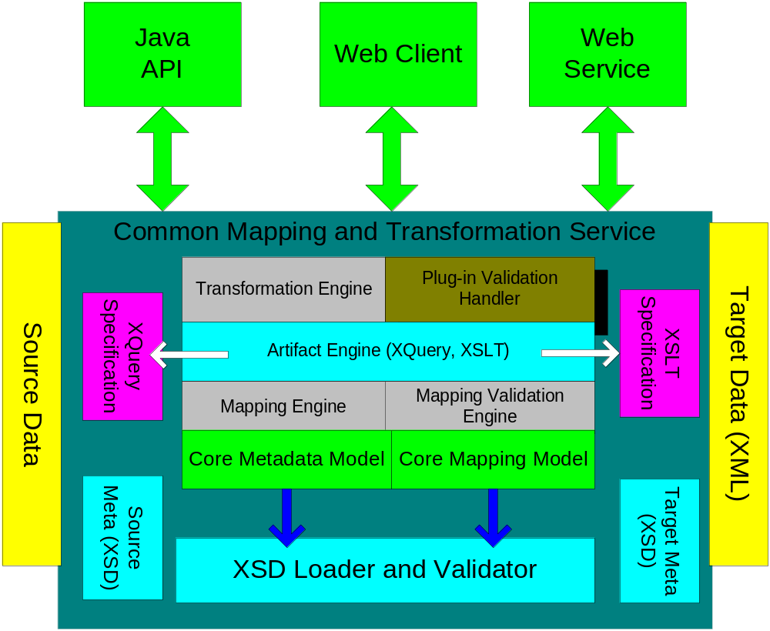
Figure 1 Architecture Diagram

Core Data Models
There are two data models:
Core Metadata Model
The unified metadata model represents the metadata (XSD) of source dataset and target dataset.
Core Mapping Model
The unified data model represents the various mapping relationship annotation, and functions based on the Core Metadata Model.
The architecture is based on the Core Data Models. Such design also makes the whole architecture highly modularized. The core modules only deal with the core functionalities, i.e., mapping, artifact generation, transformation, and validation. The other modules handle the various data formats and data models, including input and output. So it is very simple to add capabilities of supporting new data formats or implement customized validation rules. It is also very simple to replace any of the modules with better implementation, including replacing the core mapping engine.

Core Engines
Mapping Engine
The Mapping Engine handles the core task that creates and manages the mapping relationship that associates source metadata and target metadata.
Artifact Engine
The Artifact Engine generates integration artifacts for other compatible data transformation tools based on mapping between source metadata and target metadata. It supports two types of integration artifacts: XQuery 1.0 compliant artifact and XSLT 2.0 compliant artifact. The compatible transformation tools will be able to generate target dataset using the integration artifacts and source dataset.
Transformation Engine
The Transformation Engine takes the source data and mapping dataset as input and produce target dataset as output. By creating XQuery statements from the mapping data, it leverages the XQuery technology to perform the action transformation. If the input data is not XML format, it is pre-processed by an adaptor to create XML stream. Then the XML stream is forwarded to the transformation engine.
Validation Engine
The Validation Engine handles the validation of source data, mapping data, and target data. It primarily leverages the XML Schema technology to perform the validation.
Plug-in Validation Handler
The Plug-in Validation Handler provides and hooks into the Validation Engine to utilize customized validation.

Interfaces
Java API
The Java API provides a Java based interface for user to perform transformation and validations. It can integrate seamlessly into other applications.
Web Client
The Web Client provides access interface through web browser for user to create and manage mappings and perform transformation and validations. It utilizes drag-and-drop technology to provide a convenient user interface to perform such tasks.
Web service
The Web Service interface provides web service interface to invoke transformation functionalities.

Data Model Detailed Design

Core Metadata Model
The Core Metadata Model class diagram is as following.
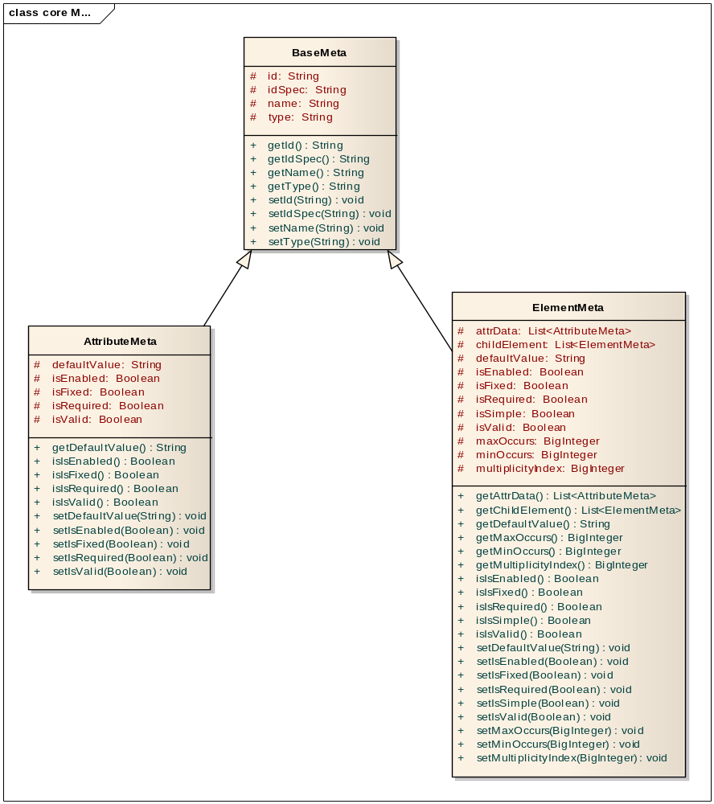
Figure 2 Metadata Model

Function Meta Model
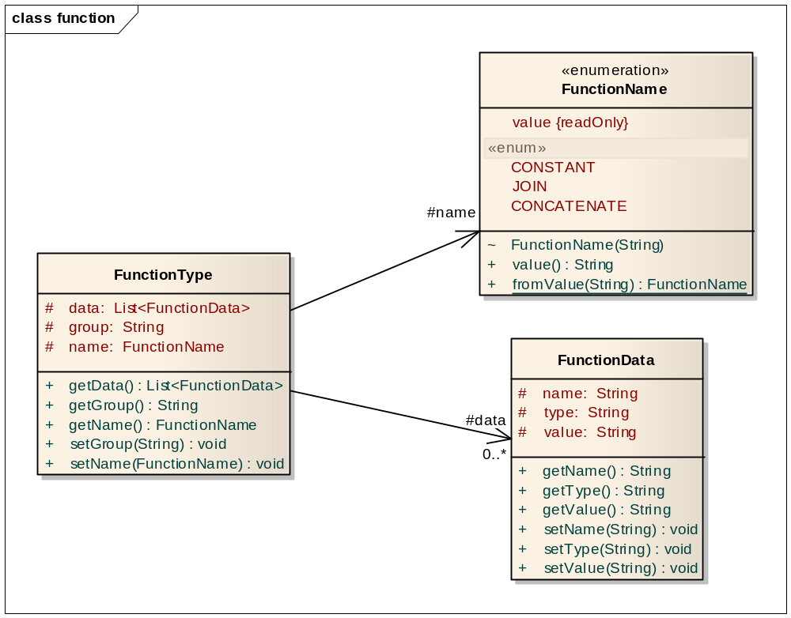
Figure 3 Function Meta Model

Component Model
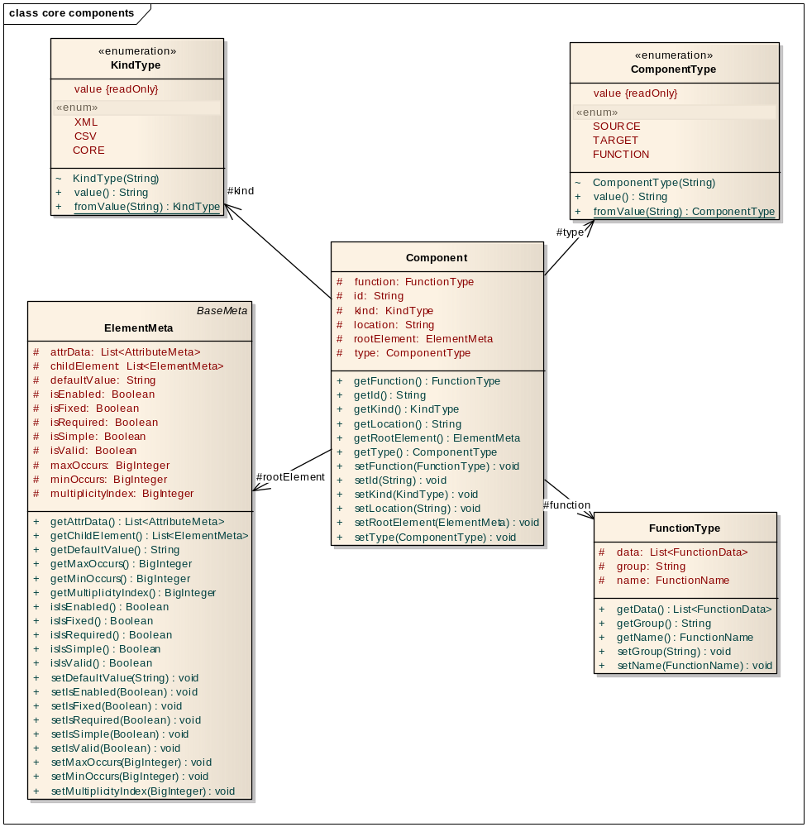
Figure 4 Component Model

Mapping Model
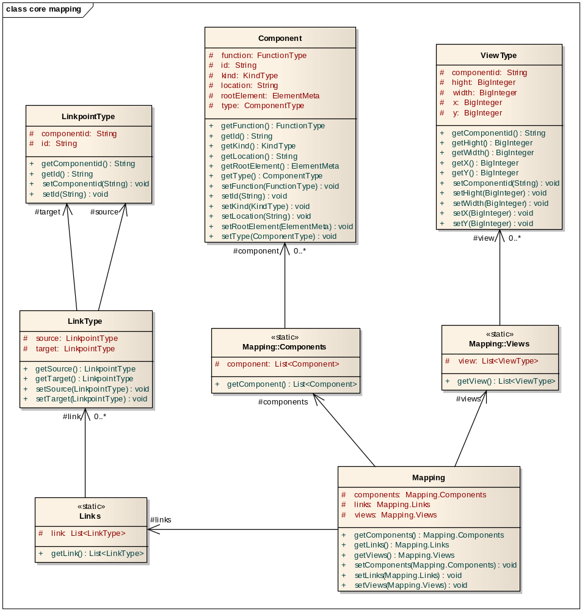
Figure 5 Mapping Model

Mapping Rules and Processing Logic

Mapping Components
Based on the Core Data Model, we have the following mapping components.
Element
Element corresponds to XML element in XML document. Each element can have zero or more attributes attached to it. It can have one parent element and zero or more children elements. The number of the same type of children elements under a parent element is called cardinality. An XML document can have one and only root element which does not have any parent element. The GUI represents an XML document is as a tree, and elements and attributes appear as nodes in the tree.
Attribute
Attributes are always attached to elements. They always appear as leaf nodes in the tree representation. An attribute always has a name. The name has to unique in the attributes associated with the same element.
The inline text of an XML element is also viewed as a special attribute of the element.
Link
A link is the basic component of mapping relationships. A link has source and target. The source and target can be data, such as elements and attributes, or function ports, such as input port, or output port of functions.
Function
Function operates on input values and derives output result. CMTS supports the normal mathematical functions, logical function and others.

Mapping Rules
Mapping rules formalize the mapping relationships and guarantee precise transformation. The following mapping rules are defined.

Matching ends
- A source attribute can only be mapped to a target attribute.
- An attribute can link to a function, and the output is still of attribute type.
- A source element can only be mapped to a target element.
- Join and filter function operates on elements and produce elements.

Hierarchical relationship
A source attribute can only be mapped to a target attribute if the enclosing source element or its ancestor maps to the enclosing target element or its ancestor.

All mapping need to be explicit
All mapping need to be explicitly specified, no implicit mapping will be allowed. This will avoid any ambiguity.

Basic Mapping Processing

Simple Element and Attribute Mapping
This is the simplest mapping scenario. An element from the source data is mapped to an element at the target, and the attributes of the source element are mapped to the corresponding attribute of the target element.
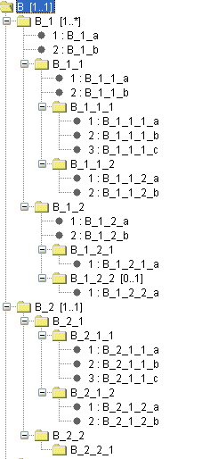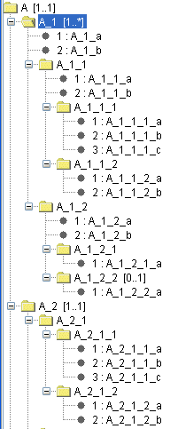
Element Mapping

Attribute Mapping
Figure 6 Simple Element and Attribute Mapping
XQuery:
<B>
<B_1>
For $x in //A/A_1/A_1_1
Return <B_1_1 B_1_1_a={$x/@A_1_1_a} B_1_1_b={$x/@A_1_1_b} />
</B_1>
</B>

Parent-child chain mapping
This is the most common mapping scenario. A chain of parents and children in source data are mapped to a chain of elements at the target, with attributes at different levels of source elements mapping to the corresponding levels of target elements.
Element Mapping

Attribute Mapping
Figure 7 Parent-child chain mapping

XQuery:
<B>
<B_1>
For $x in //A/A_1/A_1_1
Return{
<B_1_1 B_1_1_a={$x/@A_1_1_a} >
For $y in $x/A_1_1_1
Return{
<B_1_1_2 B_1_1_2_a={$y/@A_1_1_b} />
}
</B_1_1>
}
</B_1>
</B>

Parent-Child chain inverted mapping
This is a special mapping scenario that contrary to the previous mapping scenario. A chain of parents and children in source data are mapped to a chain of elements at the target, with attributes at different levels of source elements mapping to the corresponding levels of target elements. But the parent and child relationship is inverted.
Element Mapping

Attribute Mapping

Figure 8 Parent-child chain inverted mapping

XQuery:
<B>
<B_1>
For $x in //A/A_1/A_1_1/A_1_1_1
Return{
<B_1_1 B_1_1_a={$x/@A_1_1_1_b} >
For $y in $x/..
Return{
<B_1_1_2 B_1_1_2_a={$y/@A_1_a} />
}
</B_1_1>
}

</B_1>
</B>

Performance Considerations

Appendix A - References
- CMTS XQuery Recommendation Document
- W3C XML Query (XQuery), http://www.w3.org/XML/Query
- XQuery Update facility working draft, http://www.w3.org/TR/xqupdate/
- JSR 255 XQuery API for Java (XQJ)
- XQuery 1.1 requirements, http://www.w3.org/TR/xquery-11-requirements
- XQuery and XPath Full Text 1.0
- XQuery Scripting Extension 1.0 Requirements
- XQuery from the Experts: A Guide to the W3C XML Query Language, By Howard Katz, Don Chamberlin, Denise Draper, Mary Fernandez, Michael Kay, Jonathan Robie, Michael Rys, Jerome Simeon, Jim Tivy, Philip Wadler, Published Aug 22, 2003 by Addison-Wesley Professional
- XSLT - Wikipedia, http://en.wikipedia.org/wiki/XSLT
- Draft International Standard ISO/DIS 21090, http://www.kith.no/upload/4414/ISODIS21090.pdf, Voting begins on: 2008-04-24; Voting terminates on: 2008-09-24

Appendix B - Comparison between XQuery and other technology
There are also other technologies available to perform query on XML data. Mainly they are XPath and XSLT.
XPath is the common basis of XQuery and XSLT, so all its functionalities are subset of those of XQuery or XSLT. So XSLT appears as the main alternative to XQuery.
Comparing to XQuery, XSLT has the following drawbacks:

Origin
XSLT, as its name “Extensible Stylesheet Language Transformations” implies, was primarily conceived as a stylesheet language whose primary goal was to render XML for the human reader on screen, rather than querying and computations.
XSLT is stronger in its handling of narrative documents with more flexible structure, while XQuery is stronger in its data handling, for example when performing relational joins.
XSLT, by its purpose, mainly process single source XML document. While XQuery, was initially conceived as a query language for large collections of XML documents.
XSLT is good at handling “document-oriented” XML, which often have very liberal rules for nesting of one tag within another. The source document might or might not be valid according to DTD or XSD.
XSLT process document most often serially in nature: The order of elements in the result tree would usually be the same as the order of the corresponding elements in the source.
XSLT is a permissive language in its error handing: Errors in the stylesheet should result as much of the source document as possible being displayed, rather than causing a run-time error message that would mean nothing to the end user.

Usability
As a language, XQuery is much easier to use than XSLT.
- XQuery is more concise and more like other modern programming languages.
- XSLT is based on XML stylesheet format and itself an XML document. It does not follow the procedure model of other programming languages. A XSLT document is regarded as at template for the result document, which is a useful feature when larger parts of the stylesheet contain fixed, or relatively fixed, XML elements and attributes to be written directly to the output.
- XQuery is more orthogonal, in that any expression can be used in any syntactic context.
- XSLT is a two-language system in which XPath expressions can be nested in XSLT instructions but not vice versa.
- XSLT usage (XQuery from the Experts, page 146):
  - 80% for transformation from XML to HTML
  - 10% for rendering XML into other display formats, such as SVG, WML, or PDF.
  - 10% for XML to XML transformation, such as message sent between applications in an enterprise integration infrastructure

Data type
XQuery has data type build-in and XML schema aware.
XSLT 1.0 does not have data type and treat data as the general XML strings. It is also not schema aware.
XSLT 2.0 is heavily influenced by XQuery and has strong typing and schema-awareness.

Efficiency
XQuery is designed for database type of application, so it is carefully designed for optimization. It can be expected that XQuery will in general deliver better performance than XSLT.

Future Trend
XQuery 1.0 is still in very early stage, and more features are already planned for version 1.1, such as grouping, full text search, in place update, script extension, etc. All will be very useful in data mapping.

The weakness of XQuery:
XQuery is a very new technology, and only has version 1.0 releases in 2006. So the weakness is its current feature set as a whole is not as powerful as XSLT. Also the implementation is not so mature and widely available as XSLT.
XSLT 1.0 is released in 1999 and widely used and implemented. But XSLT lacks the key data typing features as XQuery and XSLT 2.0 have. But XSLT 2.0 is defined and released at nearly the same time as XQuery 1.0, so it also lacks support as XQuery.

Appendix C - Open Source Implementation

XQuery Java implementation
The leading open source Java implementation of XQuery is Saxon. Saxon implements the latest W3C standard for XPath 2.0, XSLT 2.0, and XQuery 1.0. It also supports the latest XQJ standard from Sun Java community.
But Saxon is released in two versions: Saxon-B, which is open source, and Saxon-SA, which is commercial.
Saxon-B compared with Saxon-SA, lacks the following features:
- XML Schema 1.0 Support
- Advanced Extension Functions
- Advanced Optimizer
- Streaming
- Java Code Generation
Other open source java implementation of XQuery is:
XQEngine: http://xqengine.sourceforge.net/
XQEngine is now still in development stage, and only have partial support of XQuery 1.0 standard. So it is currently not usable for our product. But we can keep track of its progress.
Currently, we recommend Saxon, the leading open source implementation of XQuery as our choice of XQuery engine. But if we follow the standard interface of XQuery, we should be able to easily replace the engine if we find better choice in the future.

XQuery Supporting packages
Xerces is the underlying XML parser used by Saxon. It is the de facto standard of open source Java XML parser, and is being used as underlying parser of almost all open source XML projects.
For using Saxon, we also recommend to use Nux, which is another open source project that provides useful wrapper around Saxon API. Though it is not necessary, it could save some developing time to integrate Saxon XQuery functionalities.

Appendix D - Rules for XML Representation of ISO 21090 Data Types
The ISO 21090 specification defined the follow rules, the following content is directly quoted from Section A.2 of Draft International Standard ISO/DIS 21090
- Any valid XML charset can be used as long as it is consistent with the String Character Set as discussed in section 6.7.5. In particular, full round-trip encoding between the String Character Set and the XML charset is required.
- xml:lang must be ignored. For content to which language applies, the Data.language or ST.language attribute must be used instead.
- All elements must be in some namespace, and the namespace must be defined in conformance statements of the information processing entities that claim conformance with this specification. The specification reserves the namespace “uri:iso.org:21090” for direct applications of the datatypes such as testing environments.
- The xml representation (and xml schema) for a type is derived algorithmically from the UML representation.
- Each type specializes ANY is represented by an XML element.
- UML Attributes with a stereotype of Binary on their type are represented as an element with text content.
  - The format of the text in the element is the format specified for the type based64Binary in W3C schema.
- UML Attributes with a stereotype of XML on their type are represented as XML with single XML element contained.
  - The name of the XML element is the name of the UML attribute
  - This is equivalent of the schema type anyType
- UML Attribute with a stereotype of XMLID are represented as an XML ID attribute. The name of the attribute is the same as the UML attribute.
- UML Attributes with a stereotype of XMLIDREF are represented as an XML IDREF attribute. The name of the attribute is the same as the UML attribute. If the type of the UML attribute is a UML collection, then the attribute will be a space delimited list of XML IDREF tokens.
- UML Attributes with a stereotype of XMLText are represented as XML text content. There may be only one UML attribute with this stereotype on a class.
- UML Attributes with a type derived from Classifier are represented as an element
  - The name of the XML element is the name of the UML attribute
  - The format of the element is hat specified bor the type following these rules recursively
- UML Attributes with a type derived from a UML primitive class are represented as an attribute
  - The name of the XML attribute is the name of the UML attribute
  - The attribute has no namespace
  - The content of the attribute must conform to the W3C schema type that matched the UML type as specified in the table below (A.3).’
  - If the value of the attribute is equal to its default value, the attribute does not need to be represented in the XML. The default value for attribute is null unless specified otherwise in the UML diagrams.
- UML Attributes with a type derived from a Collection of UML Classifiers are represented by a sequence of XML elements.
  - The name of the elements is the name of the attribute.
  - There is one element for each item in the collection
  - The format of the element is that specified for the type following these rules recursively.
- UML Attributes with a type derived from a Collection of UML primitives are represented by an XML attribute
  - The name of the attribute is the name of the attribute
  - The attribute has no namespace
  - The content of the attribute must be a space separated list of tokens that conform to the schema type that matches the UML type as specified in the table below (A.3).
- UML Association with a stereotype of “Anonymouse” are not represented by any element at all.
- The xsi:null element may be used to represented null objects as appropriate. If a UML attribute is not represented in the XML, this is identical in meaning to providing an element with xsi:null attribute.
- If the type being represented has a type other than that specified in the UML (i.e. a specialization), then the xsi:type attribute of the element must be provided. Xsi:type may be used at any time.
- The schema type name of a type is the same as its UML name, except for bound parameterized classes.
- For bound parameterized classes (where the class has type parameters) then the actual parameters bound to the class are added to the type using _ as a separator. i.e. SET(AD) becomes SET_AD
- If an attribute is contained by reference, then this is represented using XML ID/IDREF attributes. The reference must be contained within same document. The attribute itself may make other constraints about where the target of the reference might be found. The reference may be a forward reference.

